Họ tên : Lê Bảo Khánh

MSSV : 1911363

Lớp : L01

**LAB 3b**

**(**Sử dụng file http-ethereal-trace-5.**)**

**Question 1**: Select one UDP packet from your trace. From this packet, determine how many fields there are in the UDP header. (You shouldn’t look in the textbook! Answer these questions directly from what you observe in the packet trace.) Name these fields.

**ANSWER:**

Trong tiêu đề UDP có 5 field là source port, destination port, length, checksum UDP payload

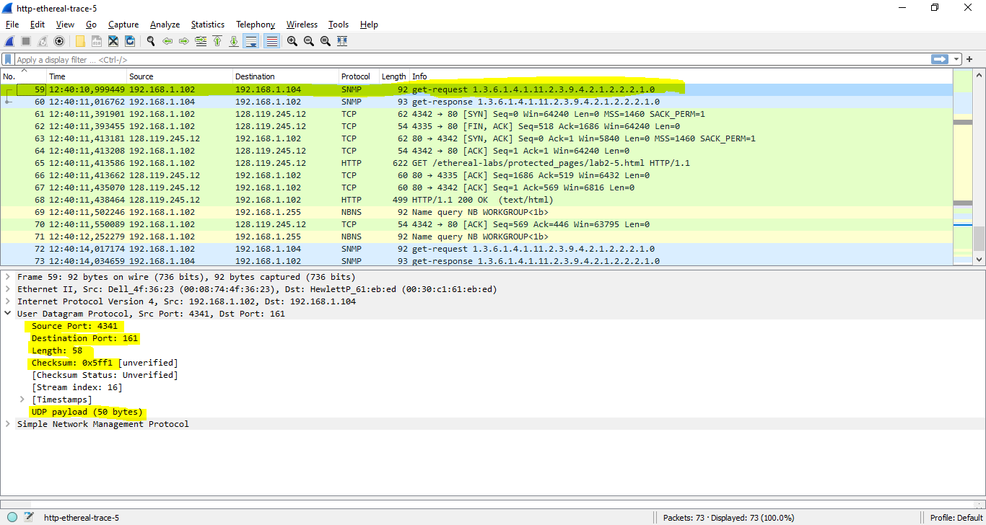

**Question 2:** By consulting the displayed information in Wireshark’s packet content field for this packet, determine the length (in bytes) of each of the UDP header fields.

**ANSWER:**

Độ dài của các header:  
- Source port: 2 bytes.

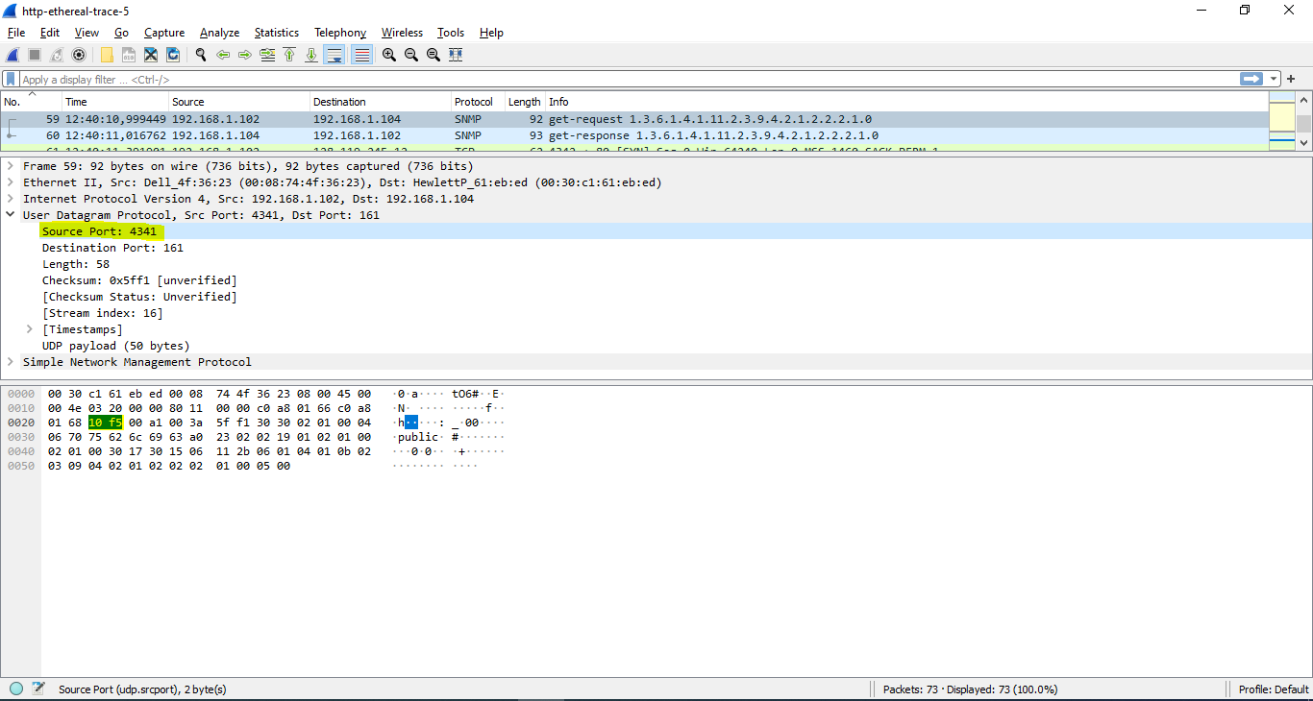  
- Destination port: 2 bytes

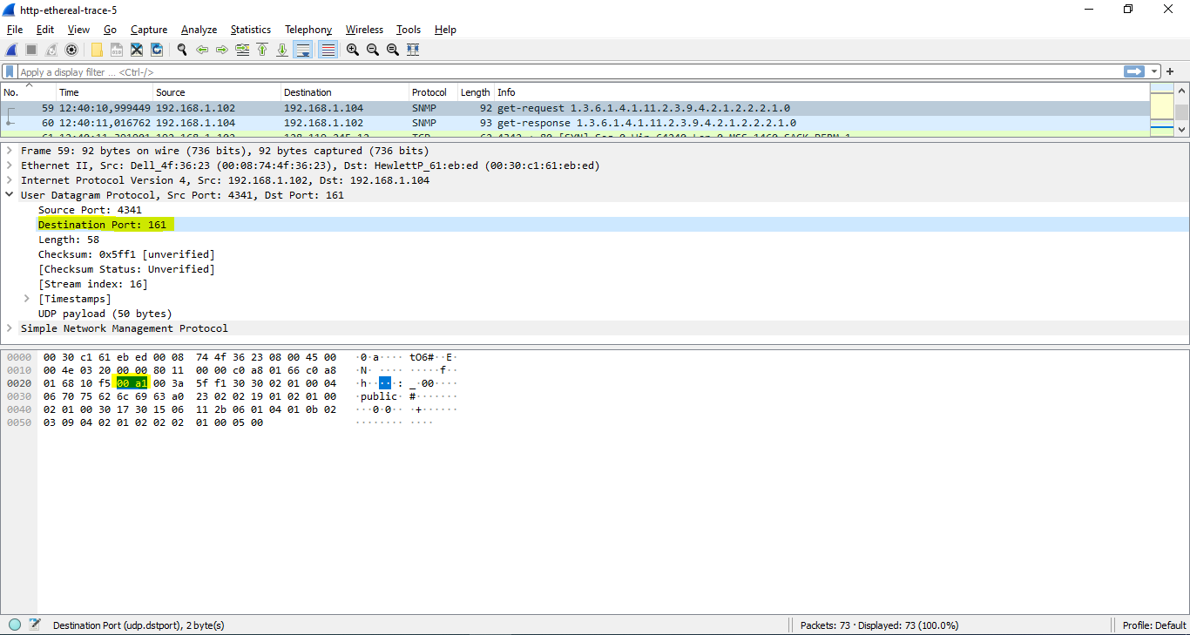  
- Length: 2 bytes

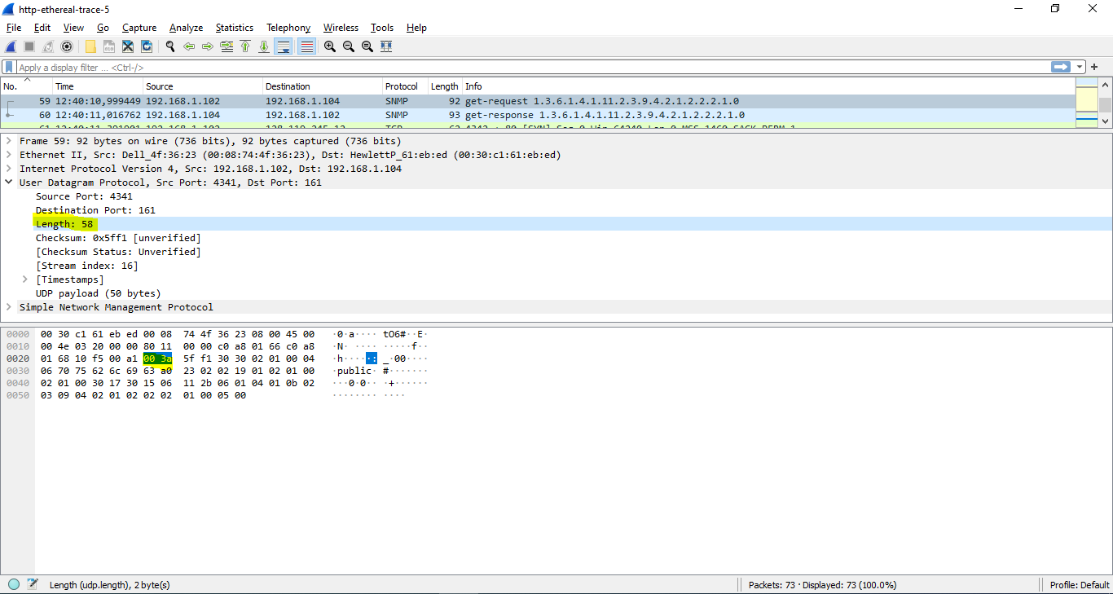  
- UDP payload: 50 bytes

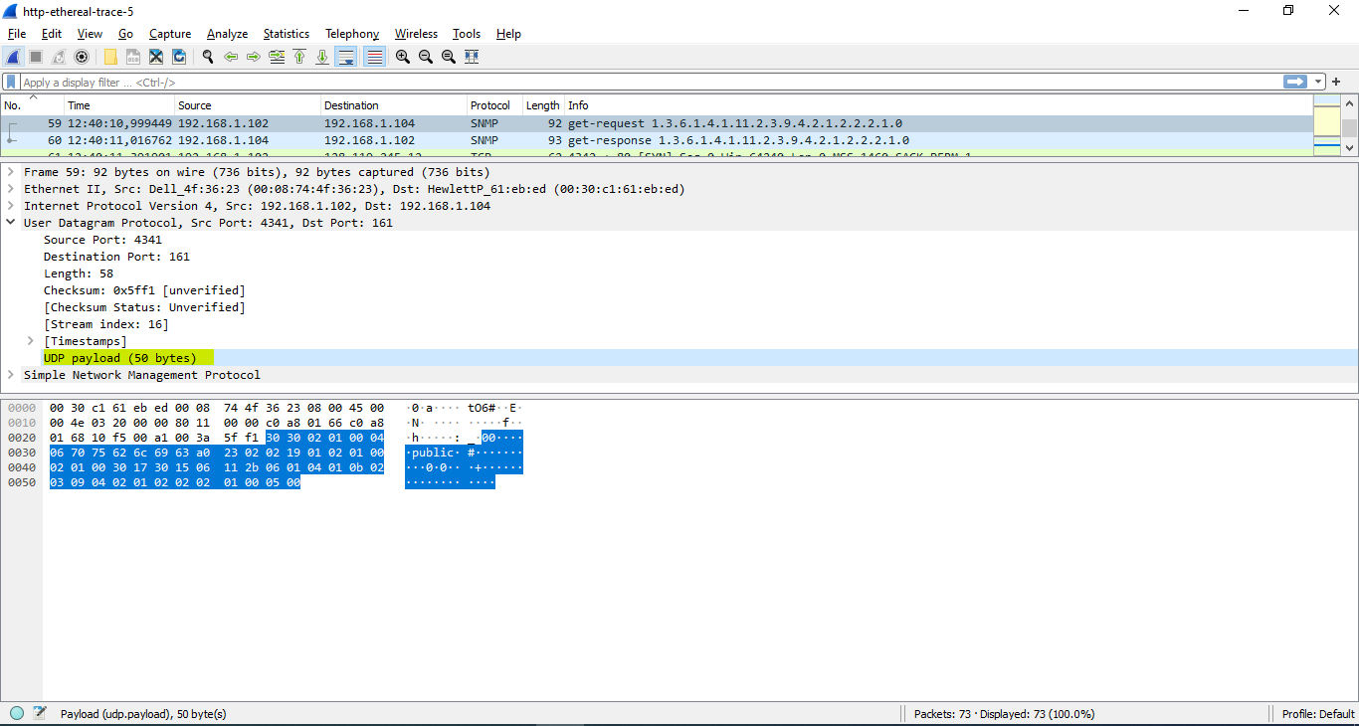

**Question 3:** The value in the Length field is the length of what? (You can consult the text for this answer). Verify your claim with your captured UDP packet

**ANSWER:**

Length filed = 59 bytes. Trong đó:

+ 8 bytes: header field

+ 51 bytes dữ liệu còn lại: trong gói tin

**Question 4:** What is the maximum number of bytes that can be included in a UDP payload?  
(Hint: the answer to this question can be determined by your answer to 2. above)

**ANSWER:**

Số lượng bytes tối đa có thể nằm trong UDP payload = 2^16 - 8 = 65528 bytes.

**Question 5:** What is the largest possible source port number? (Hint: see the hint in 4.)

**ANSWER:**

Source port number lớn nhất có thể = 2^16 = 65536

**Question 6:** What is the protocol number for UDP? Give your answer in both hexadecimal and decimal notation. To answer this question, you’ll need to look into the Protocol field of the IP datagram containing this UDP segment (see Figure 4.13 in the text, and the discussion of IP header fields)

**ANSWER:**

Protocol number for UDP = 17 (dec) = 0x11 (hex)

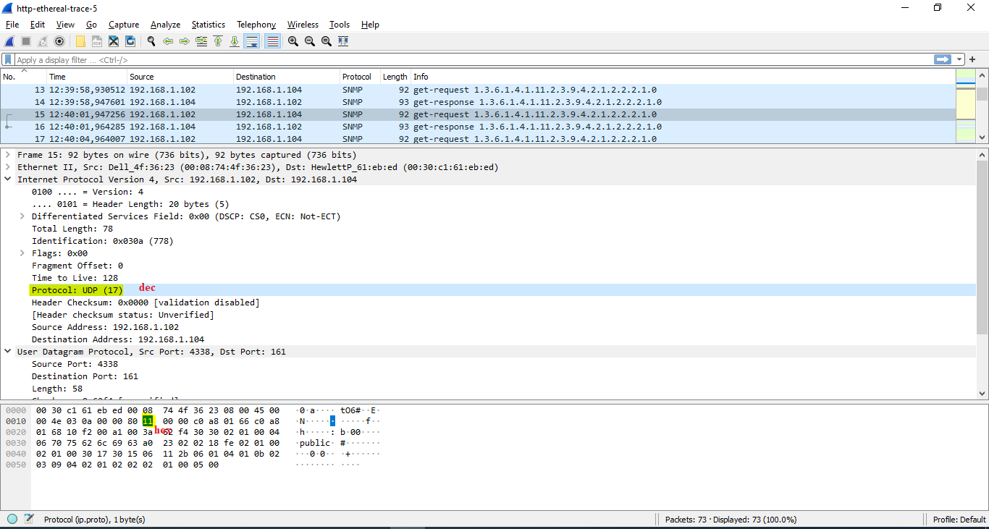

**Question 7:** Examine a pair of UDP packets in which your host sends the first UDP packet and the second UDP packet is a reply to this first UDP packet. (Hint: for a second packet to be sent in response to a first packet, the sender of the first packet should be the destination of the second packet). Describe the relationship between the port numbers in the two packets.

**ANSWER:**

Relationship:

+ Source port của gói tin gửi = Destination port của gói tin nhận.

+ Source port của gói tin nhận = Destination port của gói tin gửi.

